

KURO – Information for invitation to tender

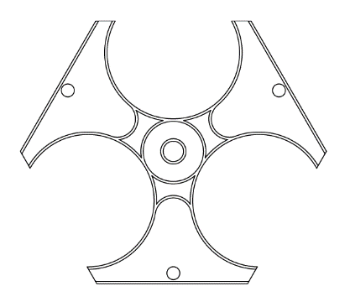

Product:

PP Spacers 3 – lined
Triangle

Information for invitation to tender:

 | Pos:....................... | PP Spacers for laying as a triangle for160 mm
 |  | Cable protection pipe / 3-lined/ System KURO o. glw.
 |  | (www.kuro-kunststoffe.de), supply and install,
 |  | as an addition to pos: ...........
 |  | Amount:............Pieces UP: ....... TP: ........

 | Pos:....................... | PP Spacers for laying as a triangle for200 mm
 |  | Cable protection pipe / 3-lined/ System KURO o. glw.
 |  | (www.kuro-kunststoffe.de), supply and install,
 |  | as an addition to pos: ...........
 |  | Amount:............Pieces UP: ....... TP: ........



